The Mixed Nuts

Set Z Last revised on 2016.09.25

Z01-Margie(KV).2016.07.18.pdf
Z02-Vienna, My City Of Dreams(KVF).2014.09.21.pdf
Z02-Vienna, My City Of Dreams(KVM).2014.09.21.pdf
Z03-Don't Take Your Love From Me(KVF).2015.10.27.pdf
Z03-Don't Take Your Love From Me(KVM).2015.10.27.pdf
Z04-Zing Went The Strings Of My Heart(KVF).2015.05.10.pdf
Z04-Zing Went The Strings Of My Heart(KVM).2015.05.10.pdf
Z05-The Very Thought Of You(KVF).2014.09.21.pdf
Z05-The Very Thought Of You(KVM).2014.09.21.pdf
Z06-Shall We Dance(KVF).2016.07.18.pdf
Z06-Shall We Dance(KVM).2016.07.18.pdf
Z07-Ain't We Got Fun(KVD).2015.05.03.pdf
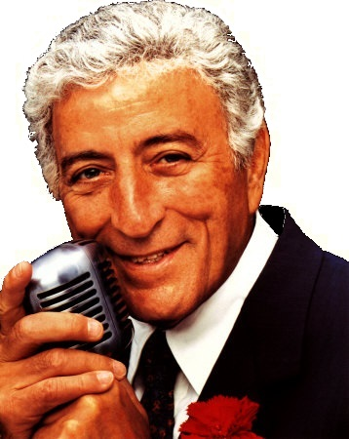
Z08-Just Walkin' In The Rain(KVF).2016.07.18.pdf
Z08-Just Walkin' In The Rain(KVM).2016.09.25.pdf
Z09-Because Of You(KVF).2015.05.10.pdf
Z09-Because Of You(KVM).2015.10.27.pdf
Z10-Stranger In Paradise(KVF).2014.09.21.pdf
Z10-Stranger In Paradise(KVM).2014.09.21.pdf
Z11-I Left My Heart In San Francisco(KV).2016.03.05.pdf
Z12-Let's Fall In Love(KVF).2016.07.18.pdf
Z12-Let's Fall In Love(KVM).2016.07.18.pdf
Z13-I've Grown Accustomed To Her Face(KVF).2015.05.10.pdf
Z13-I've Grown Accustomed To Her Face(KVM).2015.05.10.pdf
Z14-You're The Cream In My Coffee(KVD).2015.05.10.pdf
Z15-Girl Of My Dreams(KV).2014.03.02.pdf
Z16-Here's That Rainy Day(KVF).2014.09.21.pdf
Z16-Here's That Rainy Day(KVM).2014.09.21.pdf
Z17-Joshua Fit The Battle Of Jericho(K).2015.10.27.pdf

